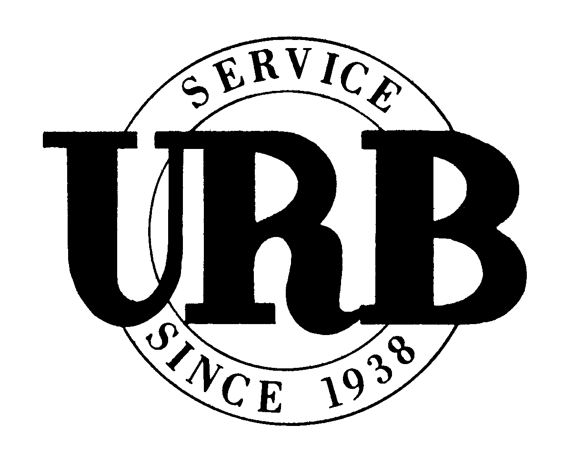
ML-341-DISC
Ed. 8/13

POLICYHOLDER DISCLOSURE NOTICE
ML-341 - Raw Milk and Raw Milk Products Exclusion

Your current policy includes an important coverage change. Please review this important notice and retain it with your insurance policy.

This Disclosure Notice is not a contract of insurance. It is intended to provide information on form ML-341 Ed. 5/13. It is recommended that you review your policy carefully to determine your duties, rights and obligations. This information is intended to assist you in the review of your policy. If there are any conflicts between this Disclosure Notice and your policy, the provisions of the policy shall prevail.

This exclusion is added to all the liability coverages, including incidental liability coverages, contained in your policy. Your liability insurance and any applicable duty we have to defend a suit does not apply to bodily injury, property damage, personal injury or advertising injury, where applicable, which is caused by or results from the production; handling; processing; packaging; bottling; distribution; exchange; sale or offer or intent to sell; or transport or delivery; of raw milk, organic raw milk or certified raw milk for direct consumption as raw milk or food products made from raw milk. This exclusion applies whether the excluded activities take place on the farm premises, insured premises or elsewhere. Raw milk as defined in this policy form means milk obtained from hoofed mammals such as cows, sheep or goats, when left in an unpasteurized state.

A copy of the ML-341 Ed. 5/13 is attached to this notice for your complete reference and review.

This is the only change to your policy by the addition of the ML-341 Ed. 5/13.

